**General**

* Overview page(s)
* Conclusion page [I ran into an error after finishing]
* It would be great if we had a way to tell people how far through all the tasks they are.
* Ordering
* Shapes [nice one to start with; also we say “first, here’s some shapes”]
* Cryptography [with intro and explanation]
* RMET
* Optimization [full battery]
* Cryptography Part 2 [note: we want to split this from the first time people do the cryptography task].
* Memory

**Overview page [TO BE COMPLETED by BW]**

Welcome etc…*BW to fill this in with text examples from other Turk studies.*

For many of these tasks, we have a PRACTICE to explain how the tasks work. They won’t be counted towards your score. But, it is important to try to get these simple questions correct, as we use them to gauge if you read and understood the instructions.

**Cryptography Task**

* Add introductory page

**Cryptography Task**

In the Cryptography Task, every letter from A to J has a numerical value. Your goal is to find out the value of each letter.

This task will take around 12 minutes.

Click continue to get more detailed instructions.

* Word changes

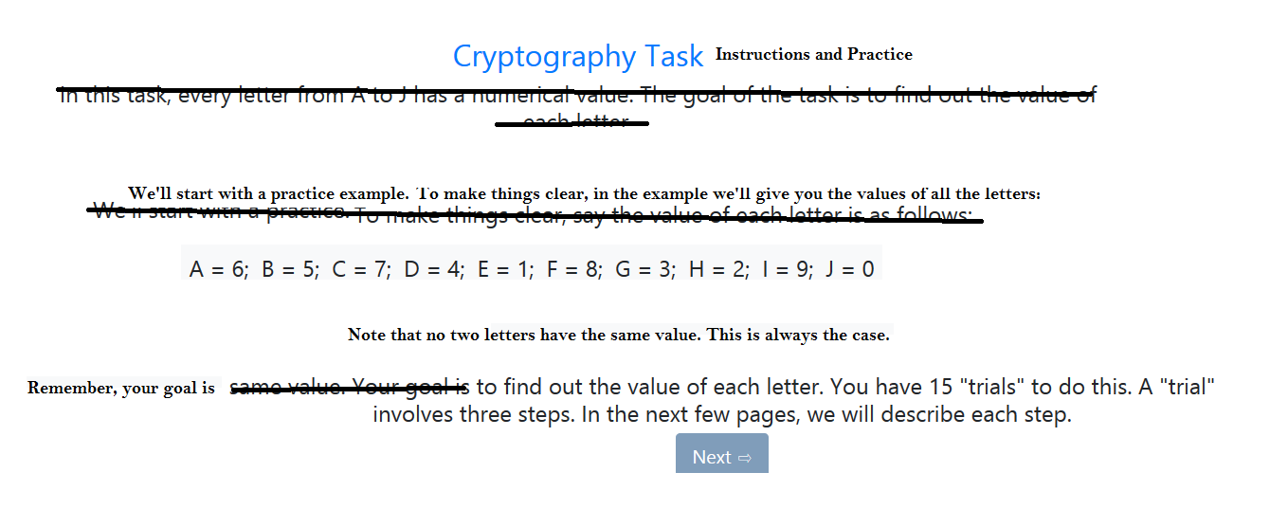

* Typo

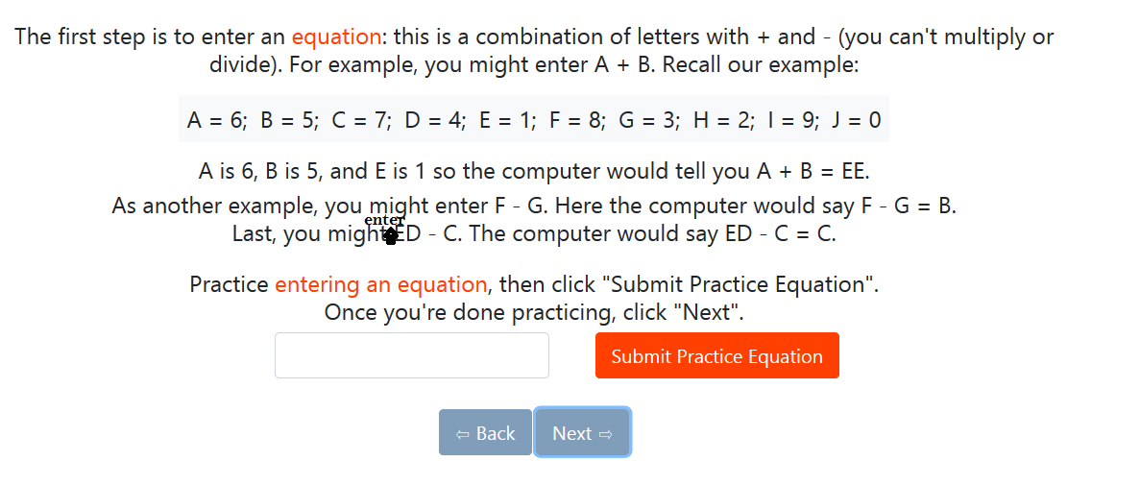

* OCD comment: can we centre the below message vertically?

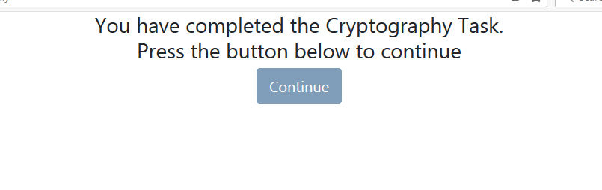

**RMET**

* Add intro page

**Reading the Mind in the Eyes Task**

In this task, you’ll be presented with pictures of people’s eyes. Your job is to draw conclusions about what the person is thinking or feeling.

This task isn’t timed; it should not take more than 10 minutes.

The next page has more detailed instructions.

* Word suggestions

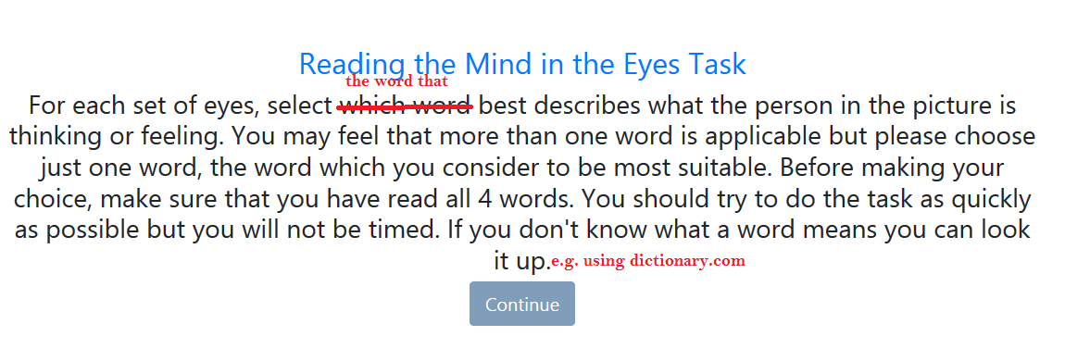

When you hit continue, the task will begin.

* Add a counter to let people know where they are:

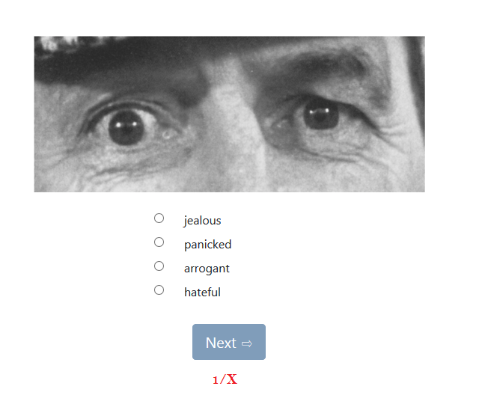

**Optimization**

* Tweak to instruction page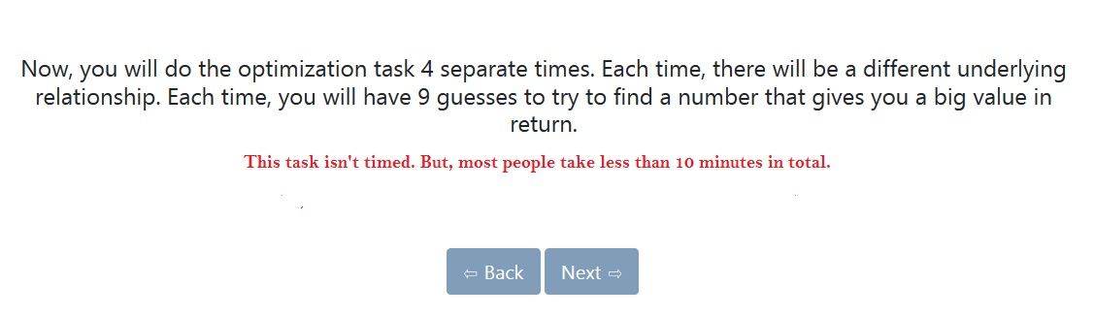
* Word change on the “interim” instructions

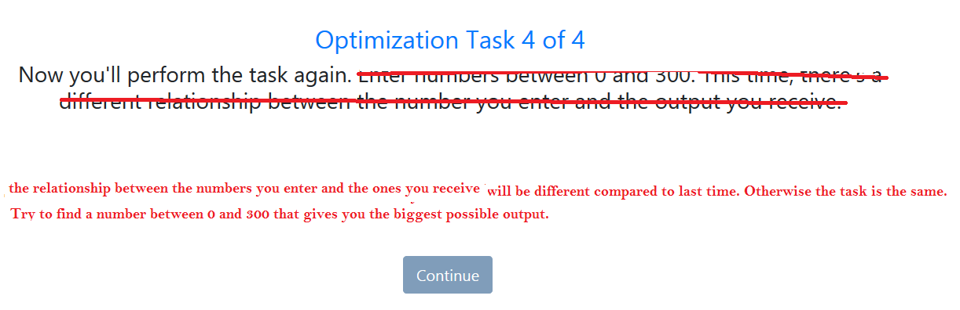

**Cryptography Part 2**

* For the second iteration, we don’t need the instructions. Let’s have an explanation page, saying the following:

**Cryptography Task – Second Attempt**

You will now attempt the Cryptography Task again.

Each of the letters from A to J has a numerical value (from 0 to 9) and your job is to find out the value of each letter.

This task is the exactly same as the one you did earlier. The only difference is that the values of the letters have changed.

On the next page, we will give a quick refresher of the instructions. Overall, this task will take no more than 11 minutes.

* The, we add the summary instruction page:

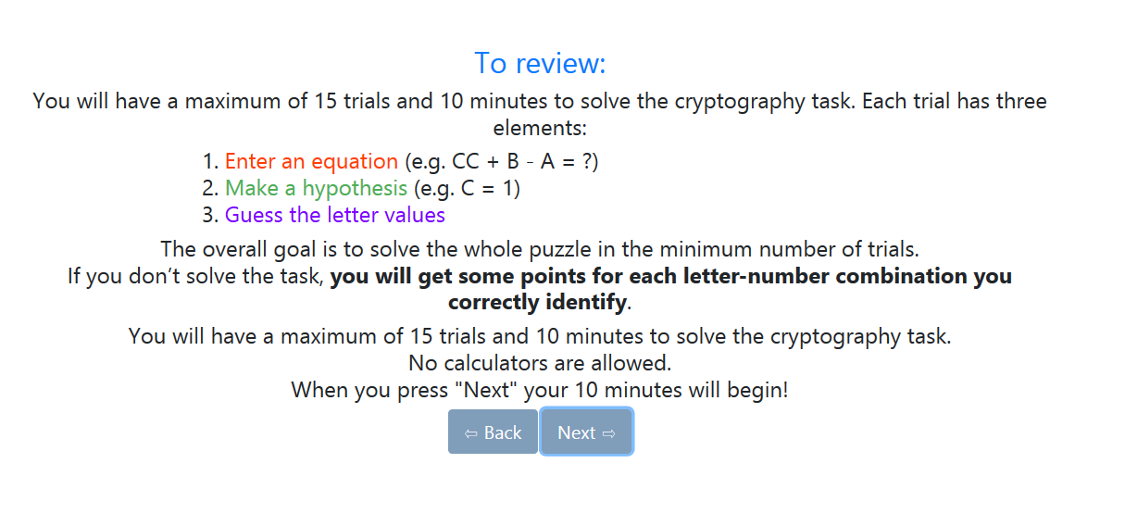

**Memory**

* As I think you mentioned in your email, we need to do a little bit of re-organization. Ideally, people would do:
* Images
* Faces
* Cars
* Words
* Set 1
* Set 2
* Stories
* Set 1
* Set2
* That way, we can avoid repeating the instructions for each of the memory types

**Conclusion page**

* This is where we tell people well done, and give them a code that they can type into Turk to get paid. I’ll write the text for this today!